**DAILY ONLINE ACTIVITIES SUMMARY**

|  |  |  |  |  |  |  |  |  |
| --- | --- | --- | --- | --- | --- | --- | --- | --- |
| **Date:** | **22 May 2020** | | | | | **Name:** | **RACHANA K N** | |
| **Sem & Sec** | **6th sem & B sec** | | | | | **USN:** | **4AL17CS070** | |
| **Online Test Summary** | | | | | | | | |
| **Subject** | | **Operation Research** | | | | | | |
| **Max. Marks** | | **30** | | **Score** | | | **30** | |
| **Certification Course Summary** | | | | | | | | |
| **Course** | **Machine Learning with python** | | | | | | | |
| **Certificate Provider** | | | **Congnitive Class** | | **Duration** | | | **6 hours** |
| **Coding Challenges** | | | | | | | | |
| **Status: Executed**  Programs to implement Simple Calculator using applets and to implement  Round Robin Algorithm in Java. | | | | | | | | |
| **Uploaded the report in Github** | | | | | **YES** | | | |
| **If yes Repository name** | | | | | **DAILY_STATUS** | | | |
| **Uploaded the report in slack** | | | | | **YES** | | | |
|  | | | | |  | | | |

Online Test Details: (Attach the snapshot and briefly write the report for the same)

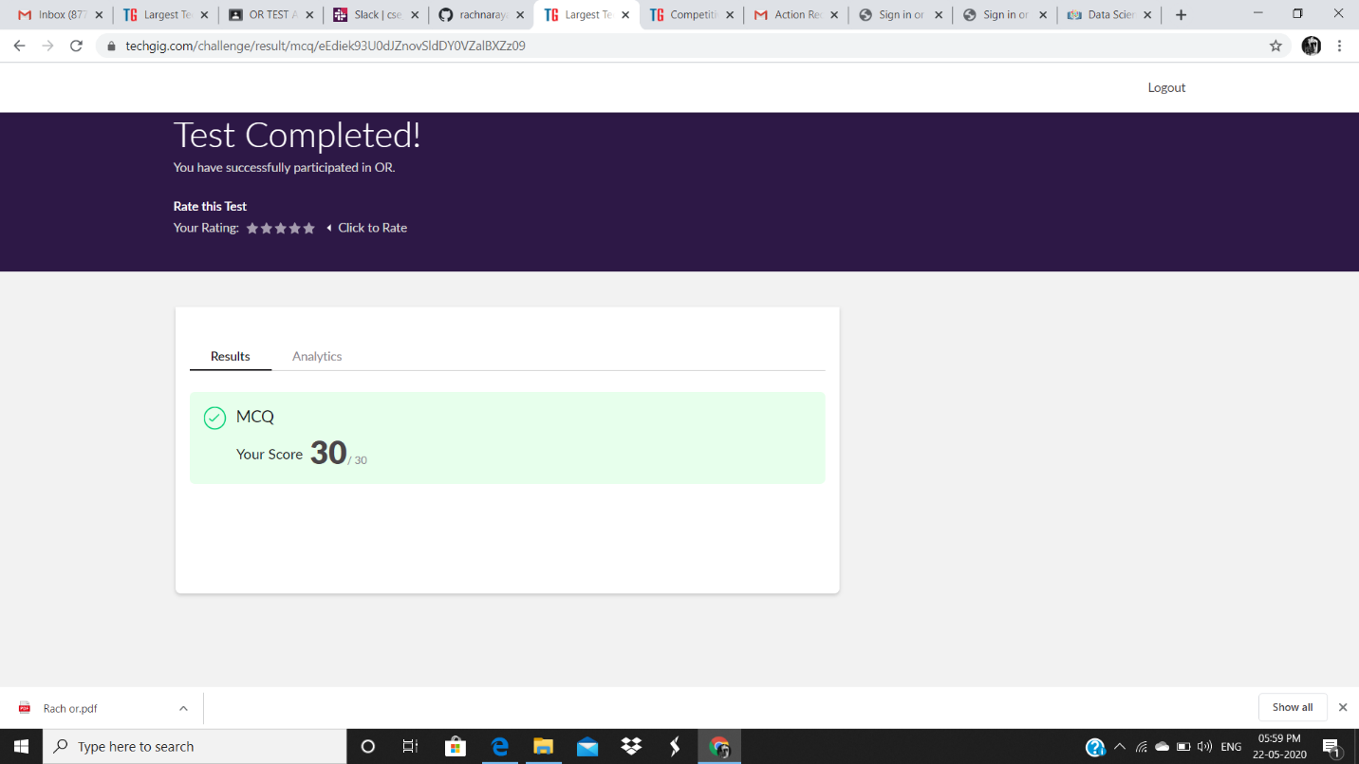

OR IA test was held today i.e 21 May 2020. There were Two rounds where each round carried marks respectively. Out of 30 marks I scored 30

Certification Course Details: (Attach the snapshot and briefly write the report for the same

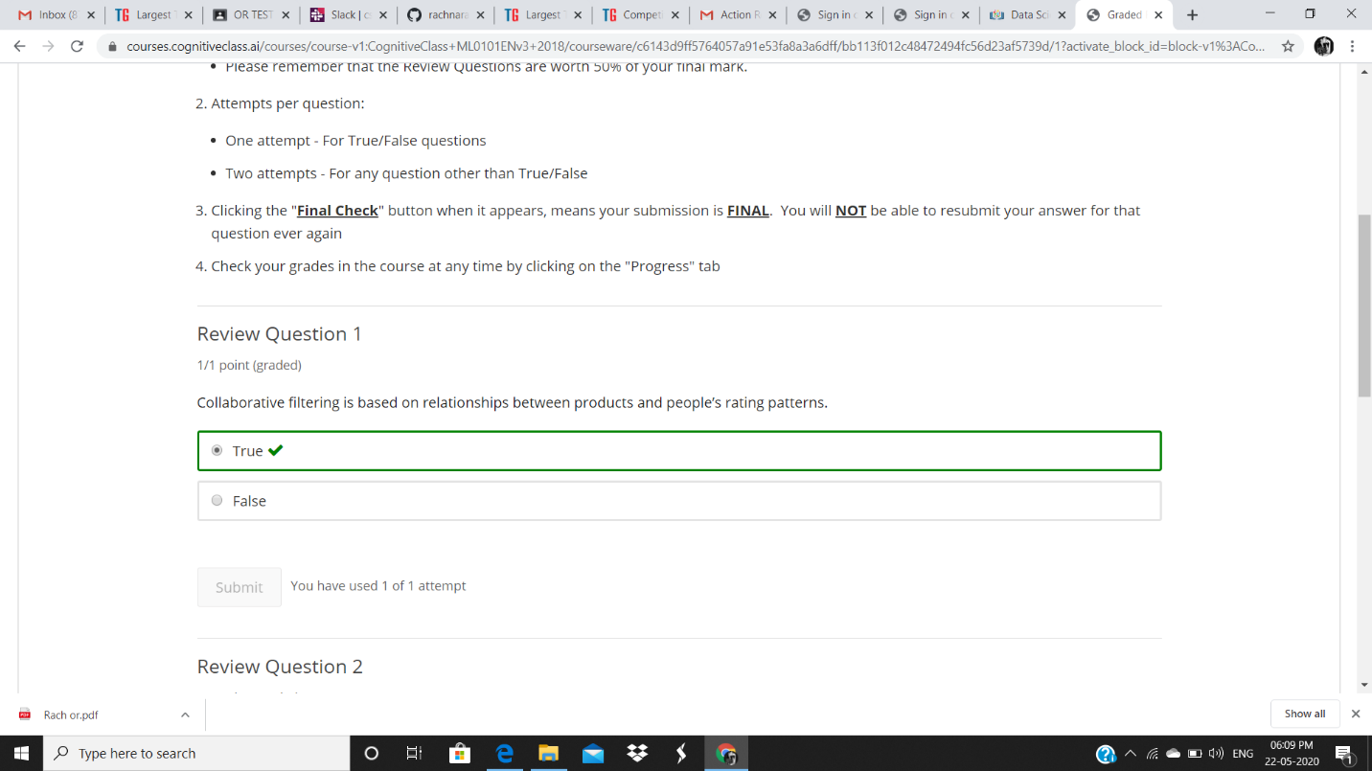

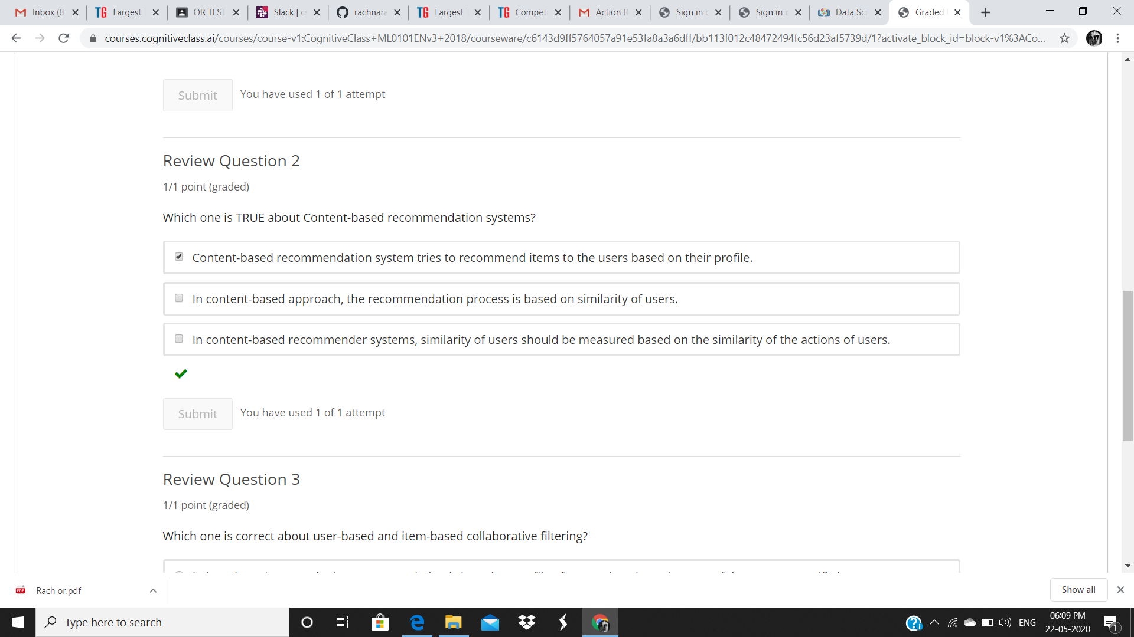

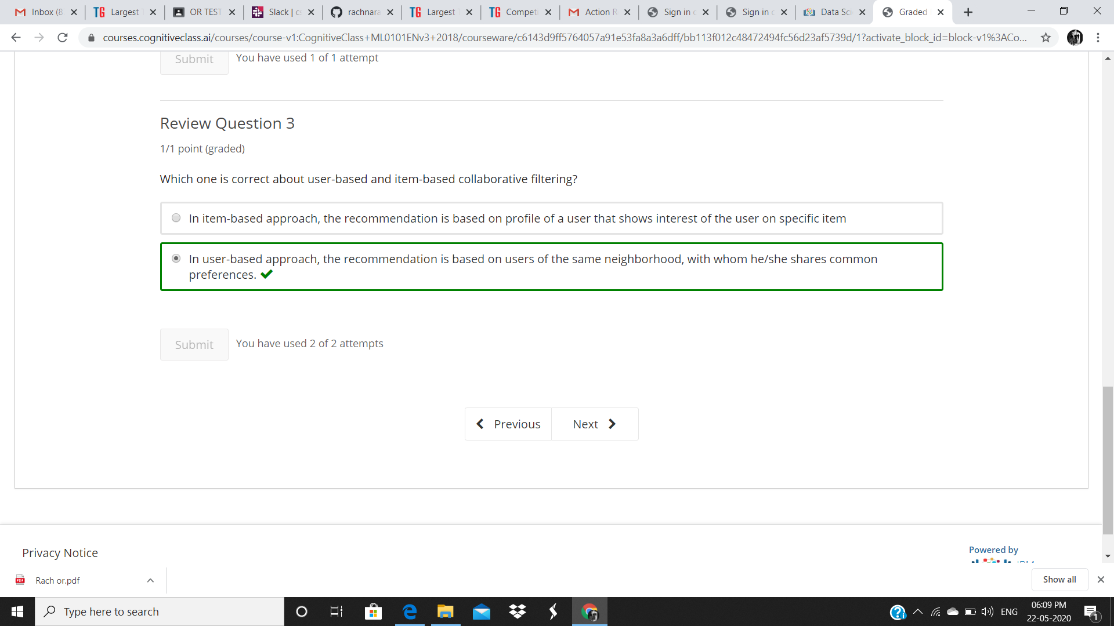

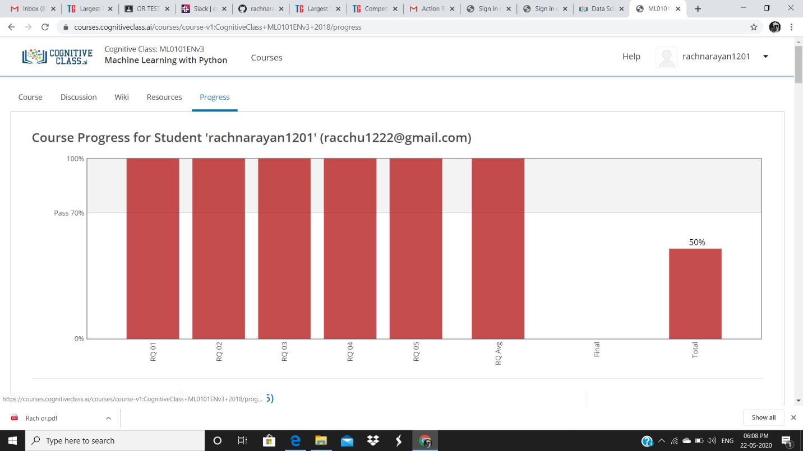

DAY 4 (21-05-2020)-Clustering, MODULE 3 Introduction to clustering, K-nearest-Clustering, Hierarchical Clustering, DBSCAN , AND REVIEW QUESTIONS ARE COMPLETED

Coding Challenges Details: (Attach the snapshot and briefly write the report for the same

Github link for detail :

https://github.com/rachnarayan1201/daily_status_coding/commits?author=rachnarayan1201